hold on

syms x n bk ak Fx fx a0;

bk=4\*(-1)^(n+1)/n;

ak=0

a0=(int(2\*x+1,x,-pi,pi))/(2\*pi)

Fx =a0+symsum(ak\*cos(n\*x)+bk\*sin(n\*x),n,1,100);

x=-pi:0.01:pi;

plot(x,vpa(subs(Fx,x)));

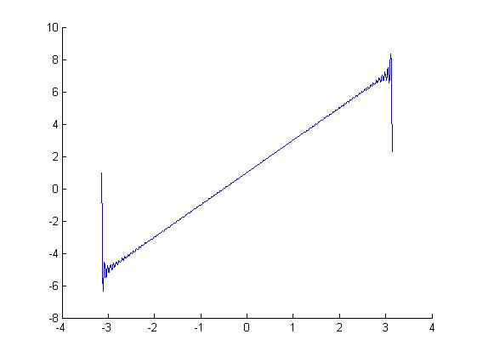

hold on

syms ck n real bk x

bk=4\*((-1)^(n+1))/n;

line([0,0],[0,1],'Color','r','Marker','o','LineWidth',2);

for x=1:1:20;

R=abs(subs(bk,n,x))

line([x,x],[0,R],'Color','r','Marker','o','LineWidth',2);

end;

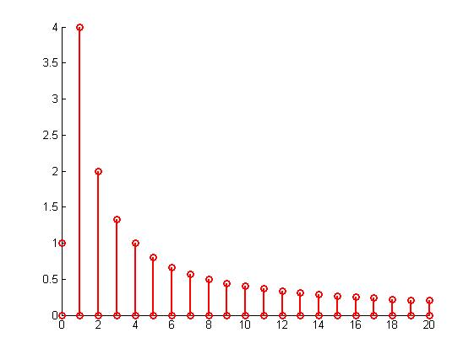

hold on;

syms x n bk p;

bk=4\*((-1)^(n+1))/n;

Fi=simplify(asin(((4\*(-1)^(n+1))/n)/abs(4\*((-1)^(n+1))/n)))

line([0,0],[0,asin(-1)],'Color','r','Marker','o','LineWidth',2);

for x=1:1:20;

p=subs(asin((-1)^(n+1)),x)

line([x,x],[0,p],'Color','r','Marker','o','LineWidth',2);

end;

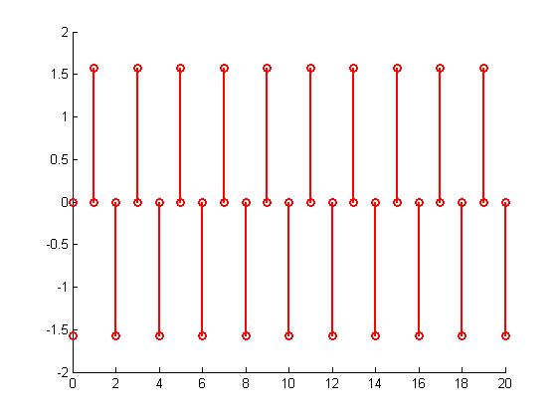

hold on

syms x fi n ak Fx fx a0;

bk=4\*((-1)^(n+1))/n;

ak=0;

fi=simplify(asin((-1)^(n+1)/abs((-1)^(n+1))))

absck=abs(4\*(-1)^(n+1)/n);

ck=simplify(absck\*(cos(fi)+1i\*sin(fi)))

ak=real(ck)

bk=imag(ck)

Fx=1+symsum(ak\*cos(n\*x)+bk\*sin(n\*x),n,1,100)

x=-pi:0.01:pi;

p=plot(x,vpa(subs(Fx)))

set(p, 'Color', 'red', 'LineWidth', 1);

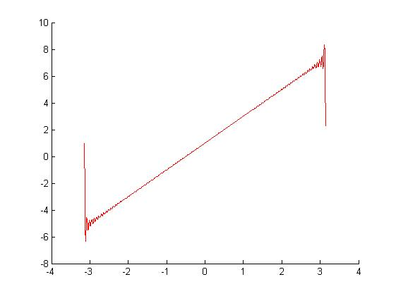

hold on

syms x w bk ak Fx fx;

fx=exp(-2\*x);

ck =int(fx\*exp(-1i\*w\*x),x,-pi,pi)/pi;

ak=int(fx\*cos(w\*x),x,0,inf)/pi%real(ck)

bk=int(fx\*sin(w\*x),x,0,inf)/pi%imag(ck)

Fx=int(ak\*cos(w\*x)+bk\*sin(w\*x),w,0,inf)

X=0:0.1:pi;

plot(X,vpa(subs(fx,X)));

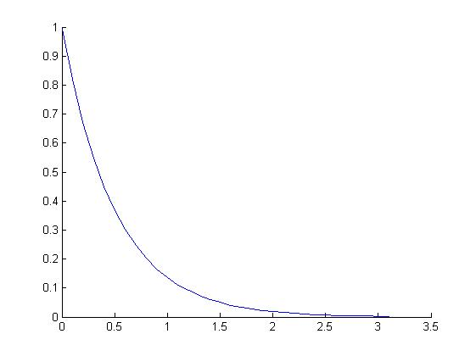

hold on

syms ck n real bk x w ak

ck=(1i\*w-2)/(w^2+4);

ak=2/(w^2+4);

bk=imag(ck)%-w/(w^2+4);

for x=0:1:15;

R=abs(subs(sqrt(ak^2+bk^2),w,x));

line([x,x],[0,R],'Color','r','Marker','o','LineWidth',2);

end;

x=0:1:15;

p=abs(subs(sqrt(ak^2+bk^2),w,x));

plot(x,vpa(subs(p)));

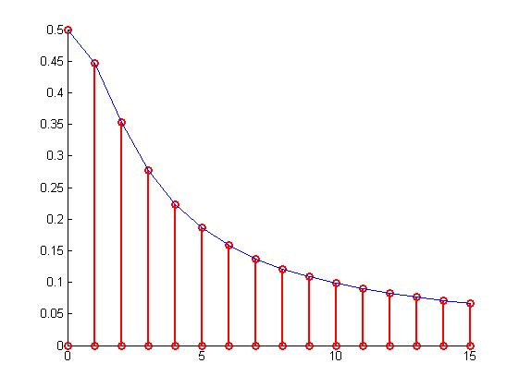

hold on;

syms x n bk p w;

ck=int(exp(-2\*x-1i\*w\*x),x,0,inf)/sqrt(2\*pi)

ak=real(ck);

bk=imag(ck);

Fi=atan(bk/ak);

for x=0:1:15;

p=subs(Fi,x);

line([x,x],[0,p],'Color','r','Marker','o','LineWidth',2);

end;

x=0:1:15;

p=subs(Fi,x);

plot(x,vpa(subs(p)));

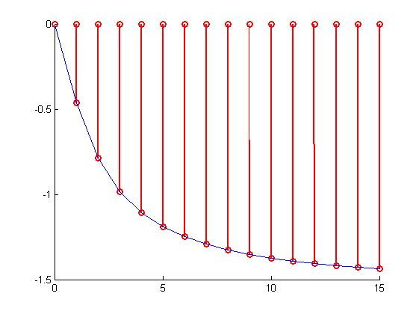

hold on

syms Fx fx f x n w Fu

f=exp(-2\*x);

W=0:0.1:10;

Fu=(int(f\*exp(-1i\*w\*x),x,0,inf))/sqrt(2\*pi);

fx=(int(Fu\*exp(1i\*w\*x),w,0,10))/sqrt(2\*pi);

ax=0:0.1:pi;

p=plot(ax,vpa(subs(fx,ax)));

set(p,'color','red');

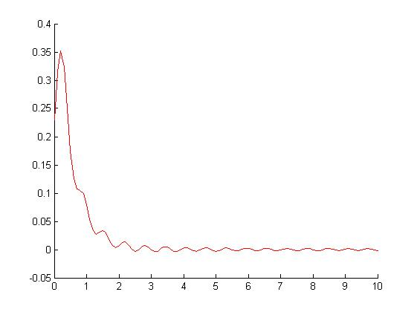

hold on

syms Fx fx f x n w Fu

f=exp(-2\*x);

Fu=(int(f\*exp(-1i\*w\*x),x,0,inf))/sqrt(2\*pi);

fx=ifourier(Fu)

fx=simplify(fx)

ax=-pi:0.01:pi;

p=plot(ax,vpa(subs(fx,ax)))

set(p,'color','red');

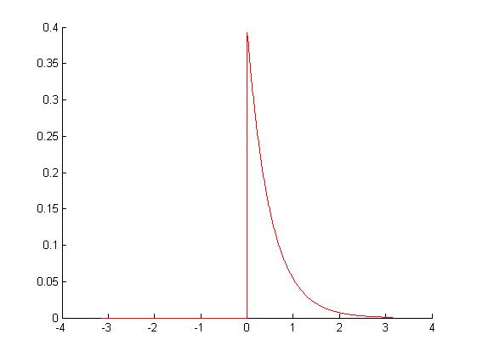

hold on

syms Fx fx f x n w Fu

f=exp(-2\*x);

Fx=fourier(f)

fx=ifourier(Fx)

ax=0:0.1:5;

p=plot(ax,vpa(subs(fx,ax)));

set(p,'color','red');

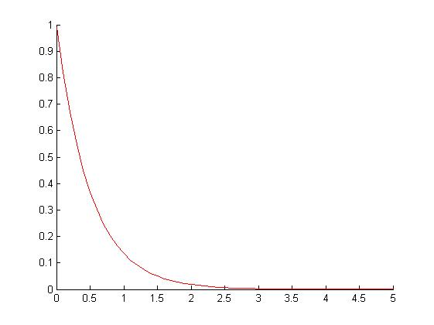

hold on

syms ck n real bk x w ak

ck=(1i\*w-2)/(w^2+4);

ak=2/(w^2+4);

bk=imag(ck)

x=0:0.1:15;

p=abs(subs(sqrt(ak^2+bk^2),w,x));

plot(x,vpa(subs(p)));

disp(simplify(sqrt(ak^2+bk^2)))

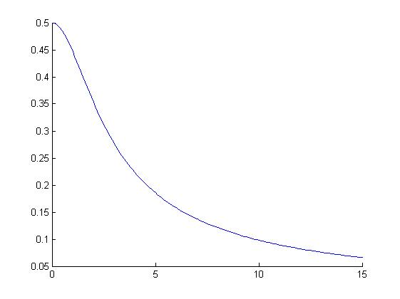

hold on;

syms x n bk p w;

ck=int(exp(-2\*x-1i\*w\*x),x,0,inf)/sqrt(2\*pi)

ak=real(ck)

bk=imag(ck)

Fi=atan(bk/ak);

x=0:0.1:15;

p=subs(Fi,x);

plot(x,vpa(subs(p)));

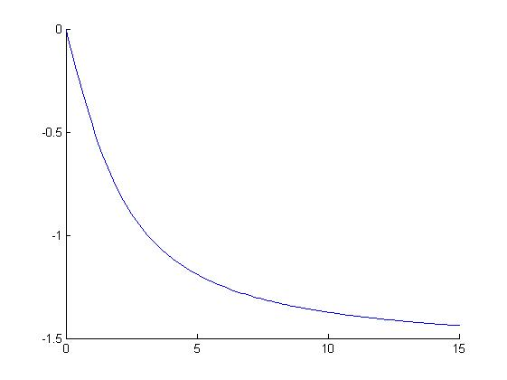

hold on

syms Fx fx f x n w Fu

f=exp(-2\*x);

Fu=(int(f\*exp(-1i\*w\*x),x,0,inf))/sqrt(2\*pi)

fx=(int(Fu\*exp(1i\*w\*x),w,-10,10))/sqrt(2\*pi);

fx=simplify(fx)

ax=0:0.1:10;

p=plot(ax,vpa(subs(fx,ax)))

set(p,'color','red');

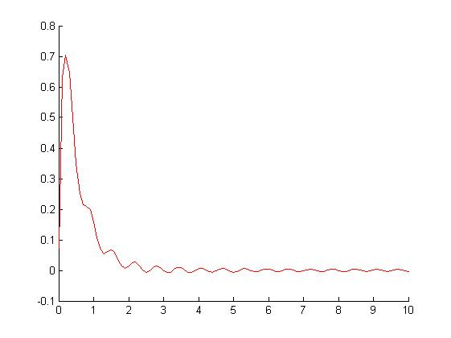

hold on

syms x Fx fx a0 w absck;

assume(0<w<pi)

ck=(2-1i\*w)/(w^2+4);

fx=(int(ck\*exp(1i\*w\*x),w,-10,10))/(2\*pi)

ax=0:0.1:10;

plot(ax,vpa(subs(fx,ax)))

